Title: Loss of large trees drives collapse of forest structure and plant biodiversity in temperate woodland

Authors: Philip Martin, Paul Evans, Elena Cantarello, Ed Mountford, Adrian Newton

Journal: Forest Ecology and Management

Abstract

There is widespread concern that human degradation of forests and climate change may cause transitions to treeless states. Much of the work on this topic has involved space-for-time substitution to estimate the potential effects of such drivers. In this study we make use of a 50 year time-series collected in Southern England in a forest that appears to be undergoing transition to a non-forest state, to (1) describe the patterns of the collapse; (2) the processes that appear to underlie this collapse and; (3) the consequences for plant biodiversity. Data on tree and ground flora were collected over two permanent transects on 3 or 5 separate occasions from 1964-2014. Our results indicate that while some plots maintained a stable basal area (BA), those that declined lost approximately 50% of their 1964 BA by 2014. Maps of plots suggested that plots that collapsed were more likely to be clumped together indicating the potential for a domino effect throughout the woodland. Vitally, once plots lost BA few showed signs of recovery – suggesting this system shows very low resilience. Changes in BA were principally driven by loss of large trees from the woodland. Where BA losses were greatest the community composition of woody species showed high turnover and sparse ground cover transitioned to areas dominated by grass species. These dramatic changes clearly resemble 'landscape traps' as described in previous forest studies. We speculate that in this case the trap may be caused by high mortality of large trees as a result of climatic changes and fungal pathogens, and the lack of recruitment caused by overgrazing of deer and ponies. Such potential traps are are major concern in the UK where much of the woodland is overgrazed and is facing emerging threats from new pathogens.

Introduction

- Human degradation, drought and other climatic changes may lead to forests transitioning to non-forest states.
- These treeless states may represent 'landscape traps' from which recovery back to forest-states may be difficult.
- Much of the work on this topic has made use of space-time analyses, making tests of resilience difficult.
- In this study we use a 50 year time-series of a previously stable woodland in Southern England parts of which appear to be undergoing transition to a treeless state.
- In this paper we aim to:
- (1) Describe the pattern of change in the woodland between 1964 and 2014.
- (2) Identify the ecological processes that might be driving the changes
- (3) Identify the consequences of these changes for plant biodiversity in the woodland

Methods
Site history and characteristics

- Denny wood is located in the New Forest in Southern England, was pollarded from 16th-18th centuries but from the 19th century management stopped and regeneration increased

Denny Wood, the site used in this study, is located in the New Forest in Southern England (Lat: 50.86, Lon: -1.53). From the 16th-18th centuries the woodland was an open oak-beech stand with some pollarding that was grazed by livestock and deer, resulting in limited regeneration. During the nineteenth and twentieth centuries pollarding stopped and regeneration increased, as did the number of beech trees. In 1870 part of the wood was fenced against livestock, though currently grazing pressure is likely to be high in both parts. For a comprehensive overview of the site’s history see Mountford et al. (1999).
- The woodland is largely composed of beech and oak, but also now contains areas dominated by grass that with few trees.
The woodland is largely comprised of beech (Fagus sylvatica) and pedunculate oak (Quercus robur) with an understory of holly (Ilex aquifolium) and birch (Betula pendula). However, the woodland also contains open areas that are relatively free of trees many of which were apparently dominated by beech and oak in the last century where vegetation now largely comprises Agrostis dominated grassy areas or bracken (Pteridium aquilinum) stands.

Data collection
- Data on trees and ground flora was collected on 3 and 5 separate occasions between 1964 and 2014 in 20x20 plots.
Data on tree and ground flora at the site was collected over two permanent transects, one in the fenced part of the woodland and one in the unfenced part. These transects were subdivided into contiguous 20x20m (0.04 ha) plots with the fenced transect containing 51 such plots and the unfenced transect 20. The fenced woodland area was surveyed in 1959, 1964, 1984, 1988, 1996 and 2014, while the unfenced transect was surveyed 1959, 1964, 1999 and 2014. On each of these occasions all stems >5cm DBH were noted, their DBH measured, their species recorded along with their location within the 20x20m plot and whether they were alive or dead. To assess ground flora a 10x10m plot was located inside each 20x20plot and the percentage cover of each species assessed.
- Data collected in the field was supplemented with trait information taken from the PLANATT databases
Data collected in the field were supplemented with plant trait information using information from the PLANTATT database (Hill et al., 2004). Ellenburg indicator values for nitrogen and light requirements of species were collated as these were thought to be those most likely to respond to changes in tree cover. Where surveys did not identify organisms to species level (E.g. Agrostis spp.) we used the mean trait values from the appropriate genus. To produce a summary of trait values in each plot community weighted mean values were calculated . To do this trait values for each species were multiplied by BA of the appropriate tree species or percentage cover for ground flora and subsequently divided by the total BA or percentage ground cover for the plot.

Statistical analyses
- Changes in BA, BA for particular tree size classes, species richness, community composition and grass cover relative to 1964 data were calculated and used in mixed models.
Prior to analyses the percentage change in BA since 1964 for each plot was calculated. Similarly we divided the trees in the transects into 4 roughtly equally sized DBH size classes based on quartiles of abundance (10-15cm, 15-25cm, 25-45cm, >45cm), and calculated the percentage change in BA since 1964 of these size classes for each plot. We also calculated the percentage change in species richness for trees and ground flora. Temporal changes in tree communities were assessed using the Tanner index, the mean of Sorensen indices calculated using BA and stem density (Chai et al., 2012). This metric allows overcomes limitations of index based on stem density or BA in which differently sized trees are treated as equal or where communities with different numbers of individuals, but with the same BA per species are considered identical (Chai et al., 2012).

- Where proportional change data was used a response variable it was logit transformed to constrain it above a loss of 100%, or zero for community similarity
Where percentage change in a variable was used as a response variable we undertook the following transformation:

where Var is the variable and Var_{max} is is the maximum value of the variable. This transformation constrains the model predictions between the minimum and maximum values observed as well improving constancy of variance (Warton and Hui, 2011). As recommended by Warton and Hui (2011) where proportion data represented zeros, as in the case of one plot which showed total loss of BA, a small non-zero constant was added to all values so that transformed values did not equal infinity. Sorensen and Tanner index values were also logit transformed to constrain them between 0 and 1. For some analyses we split the dataset into plots that ⁠
- Model selection used AICc to assess which models were 'best' and model averaging used where appropriate

We used linear mixed models in all analyses using plot number as a random effect to account for repeated measures of the same plots over time. To examine the changes in basal area between 1964 and 2014 we split the dataset into plots that declined by more than 25% of their initial BA at any point (hereafter referred to as collapsed) and those that did not. We then fit linear mixed models with an interaction between year and collapse status (collapsed or not) to identify the differences in dynamics amongst plots. We examined the spatial pattern of changes by producing maps showing the percentage decline of each plot. To determine whether plots were more likely to be close to plots that had declined in BA to a similar degree we calculated Moran's I statistic to assess between plot correlation at different lag distances from 20m-1000m – the minimum and maximum distances between plots. We determined the resilience of the woodland by producing a statistical model of the relationships between the percentage basal area decline represented by the first sign of decline in a plot and the subsequent measurements of BA and the time since collapse. We modelled resilience in this way because as BA loss increased the time taken to recover to pre-collapse BA would be expected to increase. The impact of changes in BA of trees of different size classes was assessed by producing a linear mixed model for the relationship between total BA change and change in BA for each size class. The relationships between species richness changes, Sorensen similarity and Tanner similarity and degree of collapse were all assessed using mixed models.

Results

Pattern of collapse
- Plots that collapsed tended to lose ~50% of their 1964 basal area by 2014, while stable plots increased in BA by about 10%.
- Plots that lost BA seemed to be clustered and at the local scale tests suggested there was a positive correlation between plots the dataset did not show very strong spatial autocorrelation
- In plots where basal area declined it did not tend to recover, with initial decrease in BA predicting best subsequent BA and time since BA loss having low explanatory value
- The basal are change in trees with DBH >45cm showed a very strong relationship with total plot BA losses, while relationships with changes in other size classes were weak or non-existent.
- Tree species richness changes showed little correlation to collapse severity, but turnover tended to be higher in plots that collapsed.
- Ground cover species richness increased in plots that collapsed and while turnover was not constantly correlated to collapse those plots that had lost a large proportion of their basal area showed increased grass cover

Discussion

- In this study we show that an apparently previously stable woodland is undergoing structural collapse in some areas as a result of the loss of large trees. This loss has caused rapid turnover of the tree community and a shift to a grass dominated ground flora.

Patterns of change
- The loss of BA has not been uniform or at a similar rate for all plots, suggesting differences in
- The lack of recovery suggests this system shows poor resilience, probably as a result of reduced recruitment
Ecological drivers of change
- The loss has largely been driven by death of large trees, as seen in other part of the globe

Consequences for biodiversity
- Changes in forest structure clearly affected the tree community and lead to more open grassy areas, that may represent 'landscape traps.'
- Coupled with grazing this the loss of large trees can lead to woodlands losing all tree cover with dramatic changes in biodiversity and ES.

In the context of resilience
- This site is clearly in a state of dramatic change but it is not undergoing a regime shift as defined by Carpenter etc since the pressures apparently holding the woodland in a treeless state are constant (e.g. Grazing).
- However, regardless of whether this is a regime shift it is important since many other forests throughout the world appear to be undergoing similar changes.
- It may be difficult to restore such sites once they become heavily degraded

Conclusion

References
Chai, S.-L., Healey, J.R., Tanner, E.V.J., 2012. Evaluation of forest recovery over time and space using permanent plots monitored over 30 years in a Jamaican montane rain forest. PLoS One 7, e48859. doi:10.1371/journal.pone.0048859
Hill, M.O., Preston, C.D., Roy, D.B., 2004. PLANTATT - attributes of British and Irish plants: status, size, life history, geography and habitats.
Warton, D.I., Hui, F.K.C., 2011. The arcsine is asinine: The analysis of proportions in ecology. Ecology 92, 3–10. doi:10.1890/10-0340.1

Figures

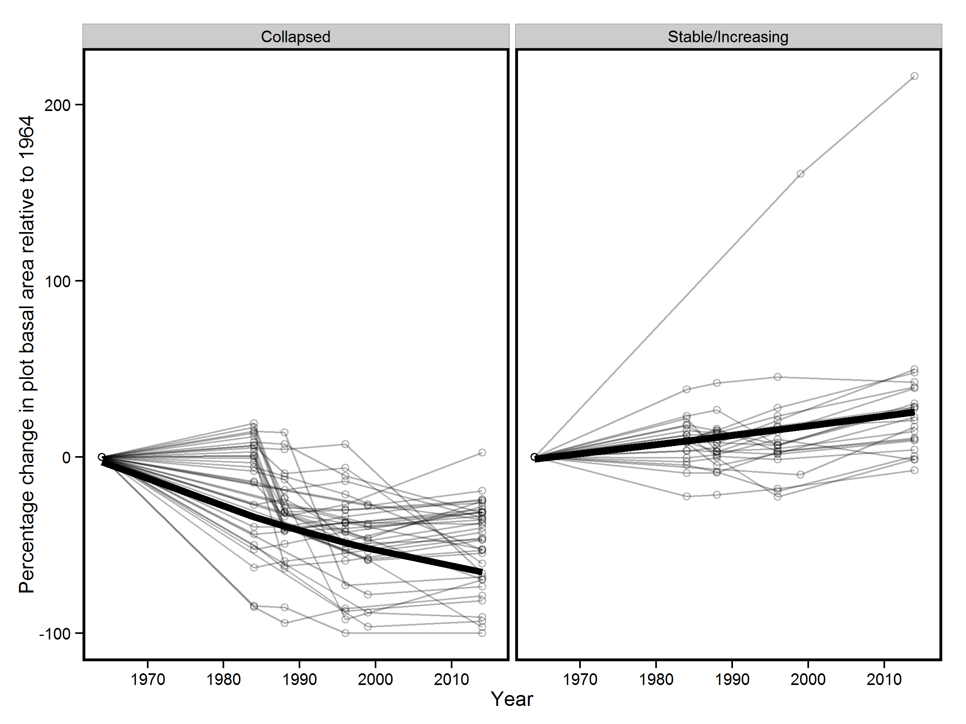
Figure 1

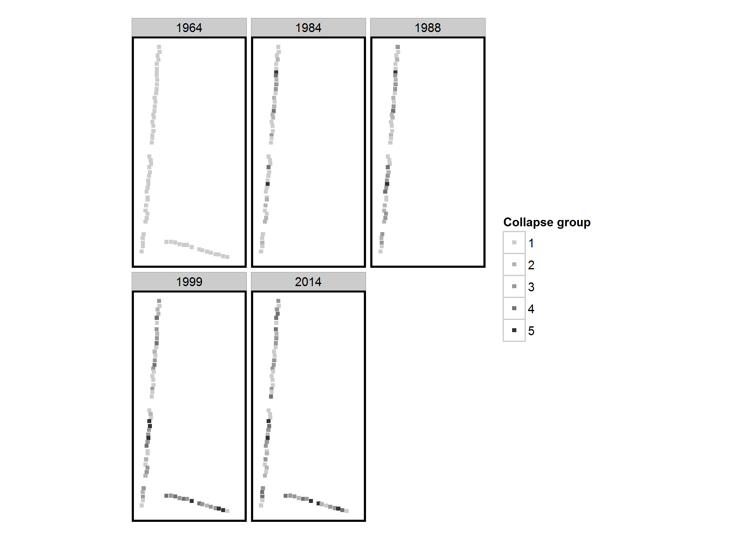
Figure 2

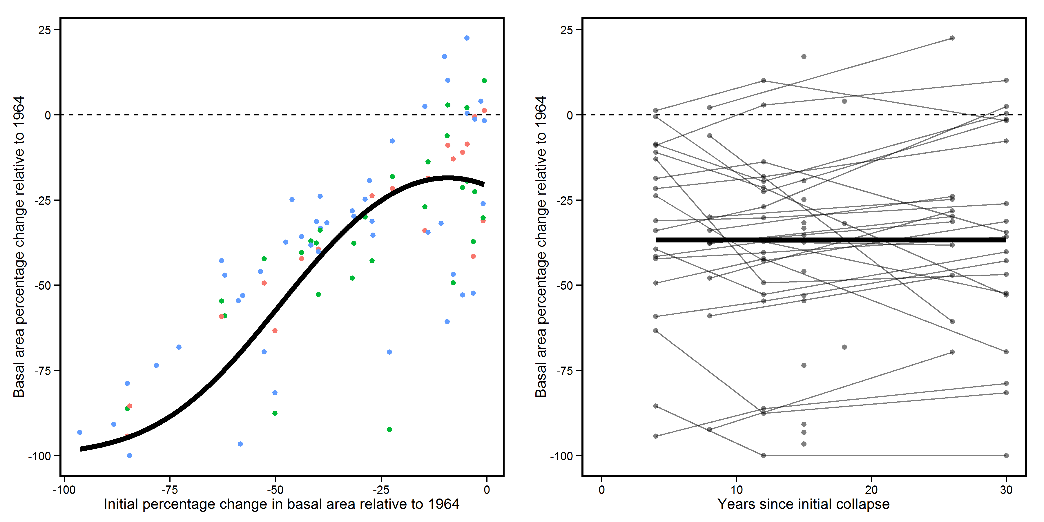
Figure 3

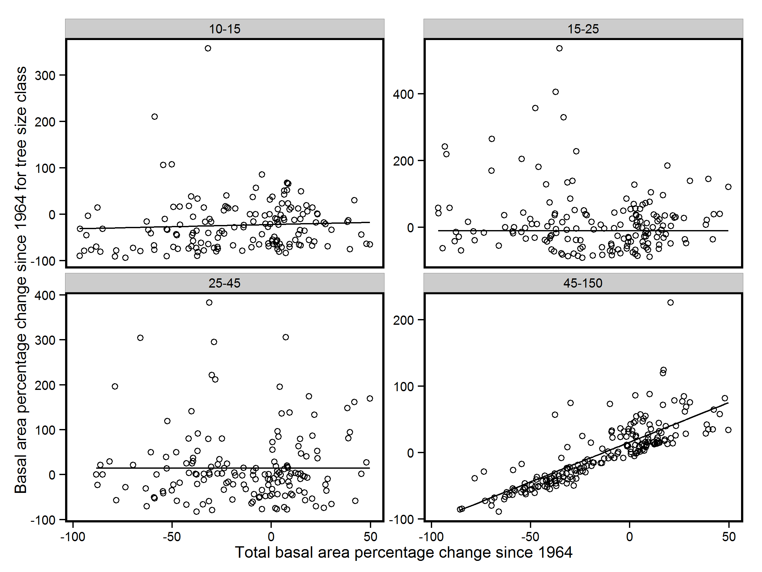
Figure 4

